**External Examiners Reporting System**

**Report submitted offline - new process introduced**

Available for College Key Contacts

College Key Contacts have the ability to mark reports as submitted offline where the report will not be completed and submitted through the EERS system.

College Key Contact may view all reports for schools within the College by clicking on the College Reports tab:-

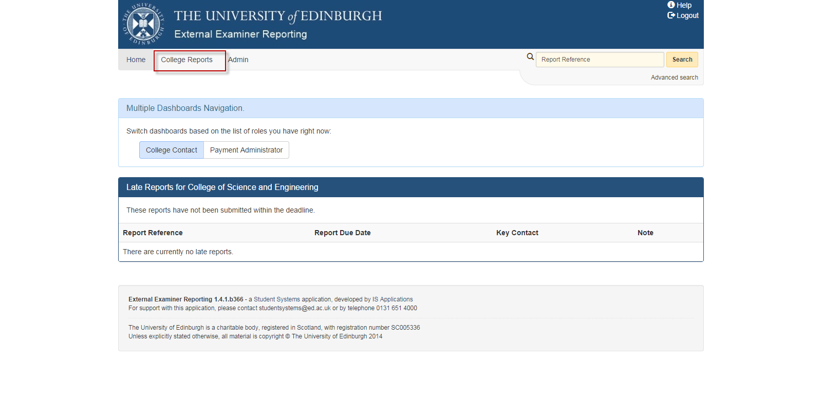

This will present a list of all reports within the college together with the status of the reports.

Reports in either Allocation or Draft Report status can be marked as submitted offline.

Click on the report id of the report you wish to mark as submitted offline.

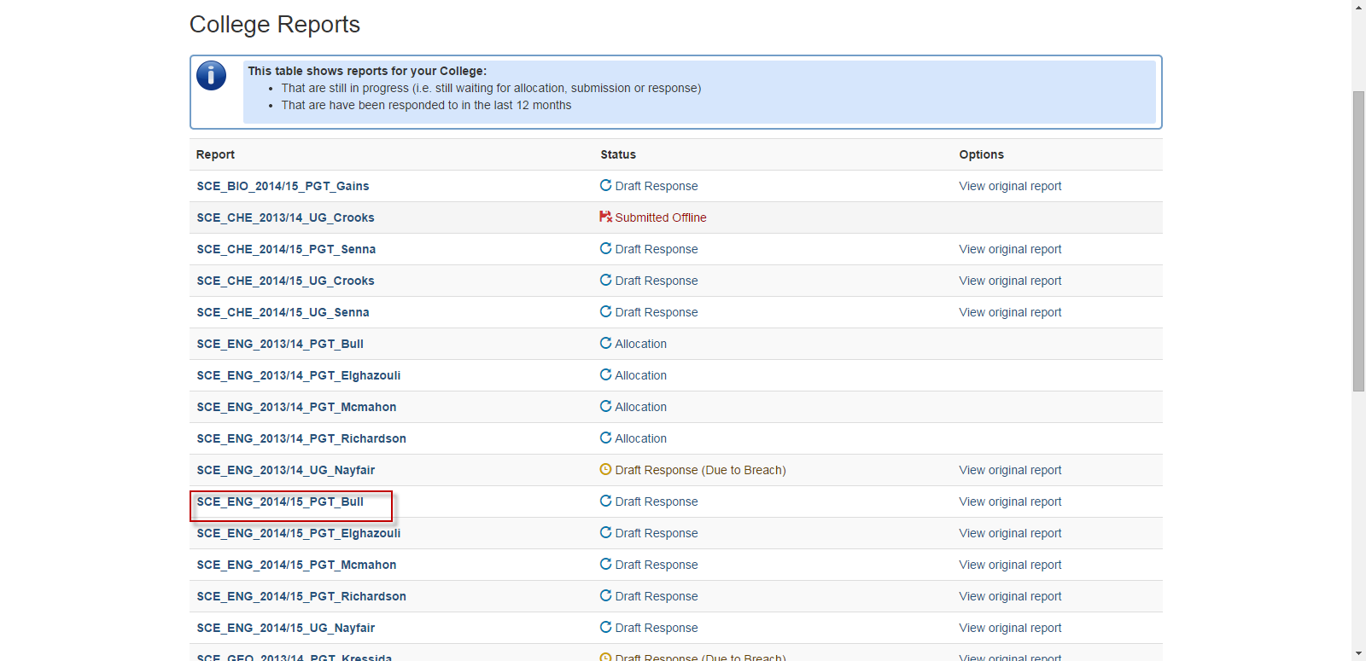

In the report summary container you are presented with a tick box and a ‘Save’ button. To proceed, click on the tick box and ‘Save’ button:-

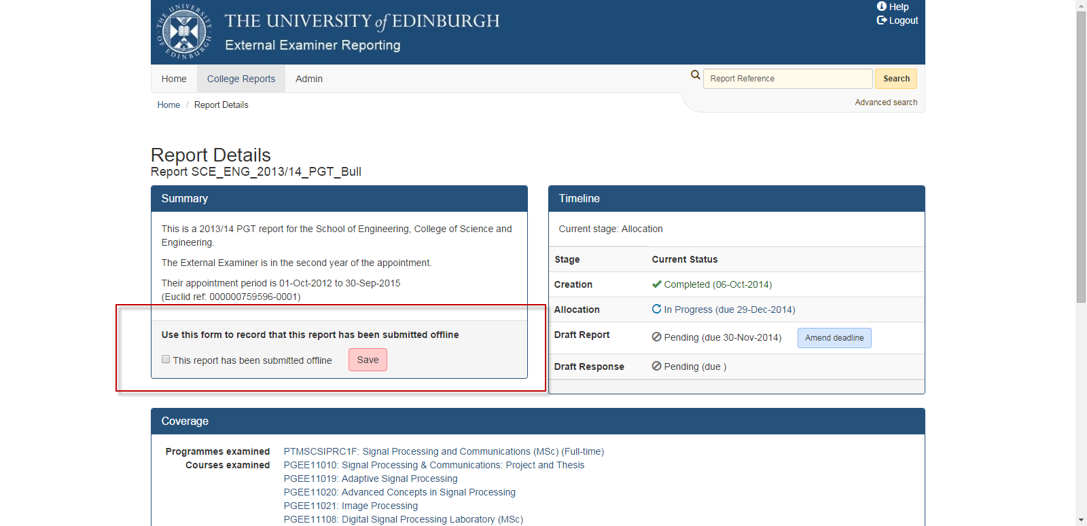

You will be presented with confirmation:-

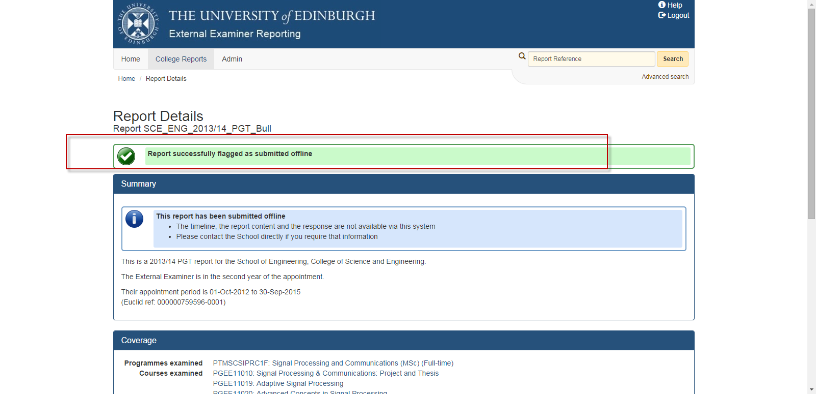

If the report was in Allocation status, it will be removed from the School Key Contact Allocation container.

If the report was in Draft Report status, it will be removed from the External Examiner Active Report container and appear in the Previous Report container. The Report will no longer appear on Response coordinator dashboard.

Both the School Key Contact and College Key Contact will see a status of ‘Submitted Offline’ when they view all reports in their school or college reports:-

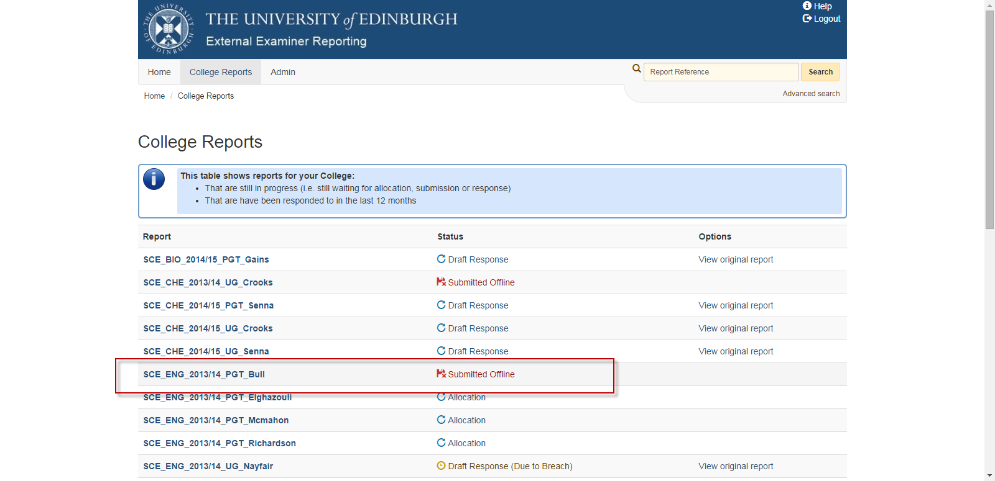

The report will still be searchable and the search results display will show ‘Submitted offline’:-

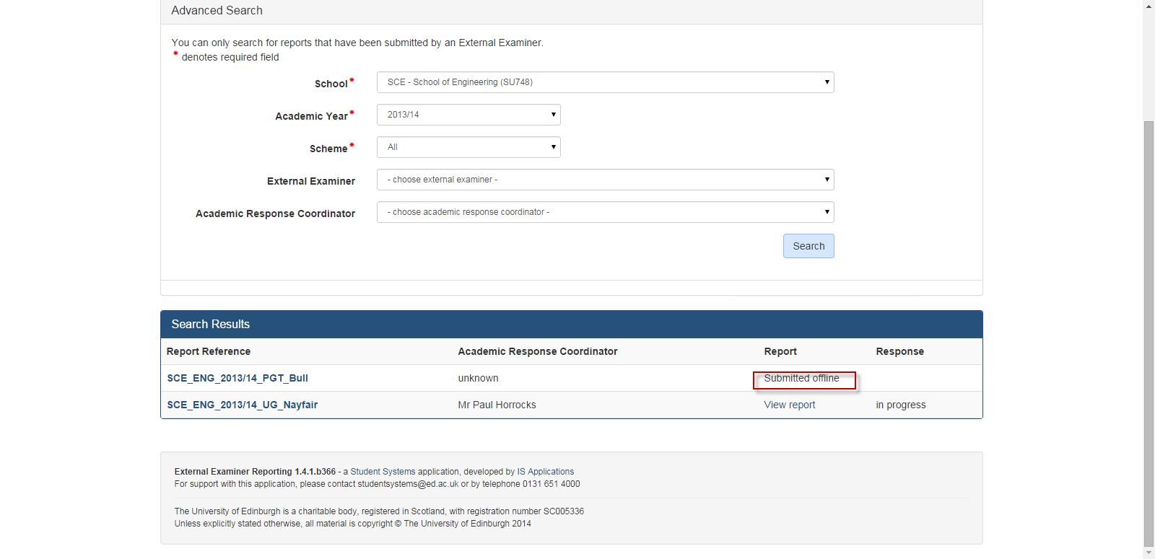

If you view the report summary details, you are informed the report has been submitted offline:-

