# **How to undo disregarded components**

There are two ways you can undo disregarded components:

1. From the "Disregard Components" screen
2. From an individual student's “little i button”

This document includes instructions for both methods.

# **From the Disregard Components screen**

Processing this task from the Disregard components screen allows you to undo disregarded components in bulk for one or more students, items, components, or assessments.

## Process Overview

**1.** Click the “Disregard components” button

**3.** Select the students, items, components, or assessments you want to undo

**2.** Click view/undo disregarded components

**5.** Click continue

**4**. Click undo selected

## Step by Step Instructions

### Click the “Disregard components” button

This button is on the Assessment Hub home page at the bottom of the screen:

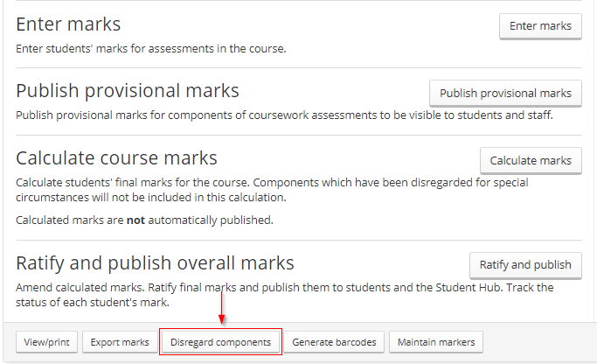

### Click the “View/undo disregarded components” button

This button will only appear if components have already been disregarded from this course.

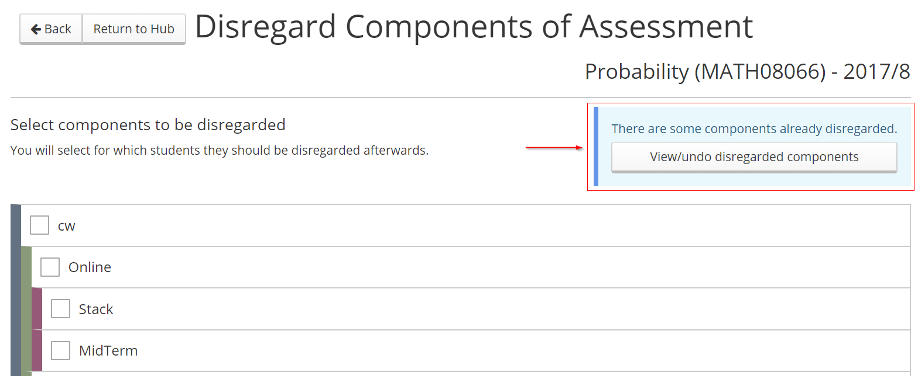

### Select the students, items, components, and/or assessments you want to undo

You can choose the “select all” boxes or individual boxes for students, items, components or assessments.

* Once you have selected something, a tick will appear in that box. A tick may also appear in other boxes if it means everything in that section is now selected.
* A horizontal line will appear in a box if something in that section has been selected but not everything.
* There is some logic built into the screens so if, for example, a whole assessment was previously disregarded and you undo an item within that assessment, the assessment itself has to be undone as everything underneath it is no longer disregarded.

For example: in the screenshot below the box for item “H03” was selected for the first student. As this is the only thing they had disregarded, a tick has also appeared in the box beside their name.

There are horizontal lines in the “select all students” box on the left, and in the “select all H03” box to show something in that section has been selected but not everything.

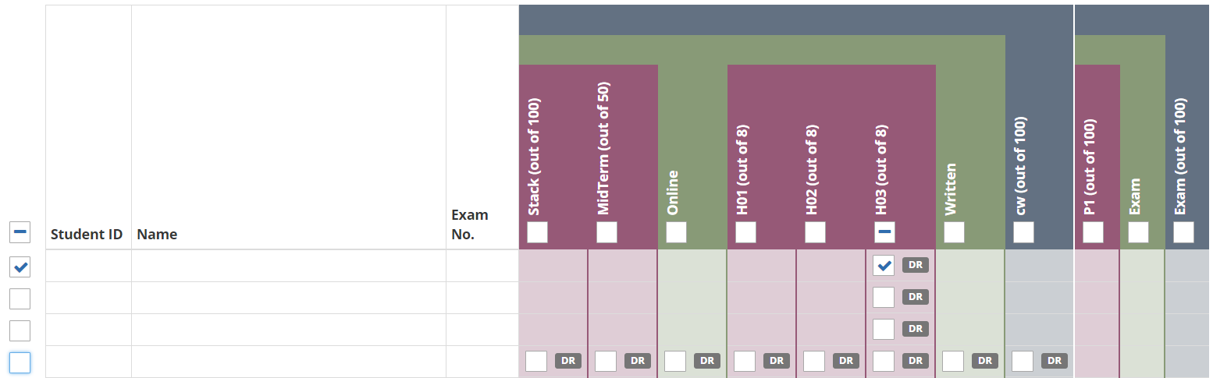

Follow steps 3.1 – 3.4 below depending on your scenario:

#### Undo for some students – only certain items, components, or assessments

Tick the item, component or assessment boxes on the student’s line:

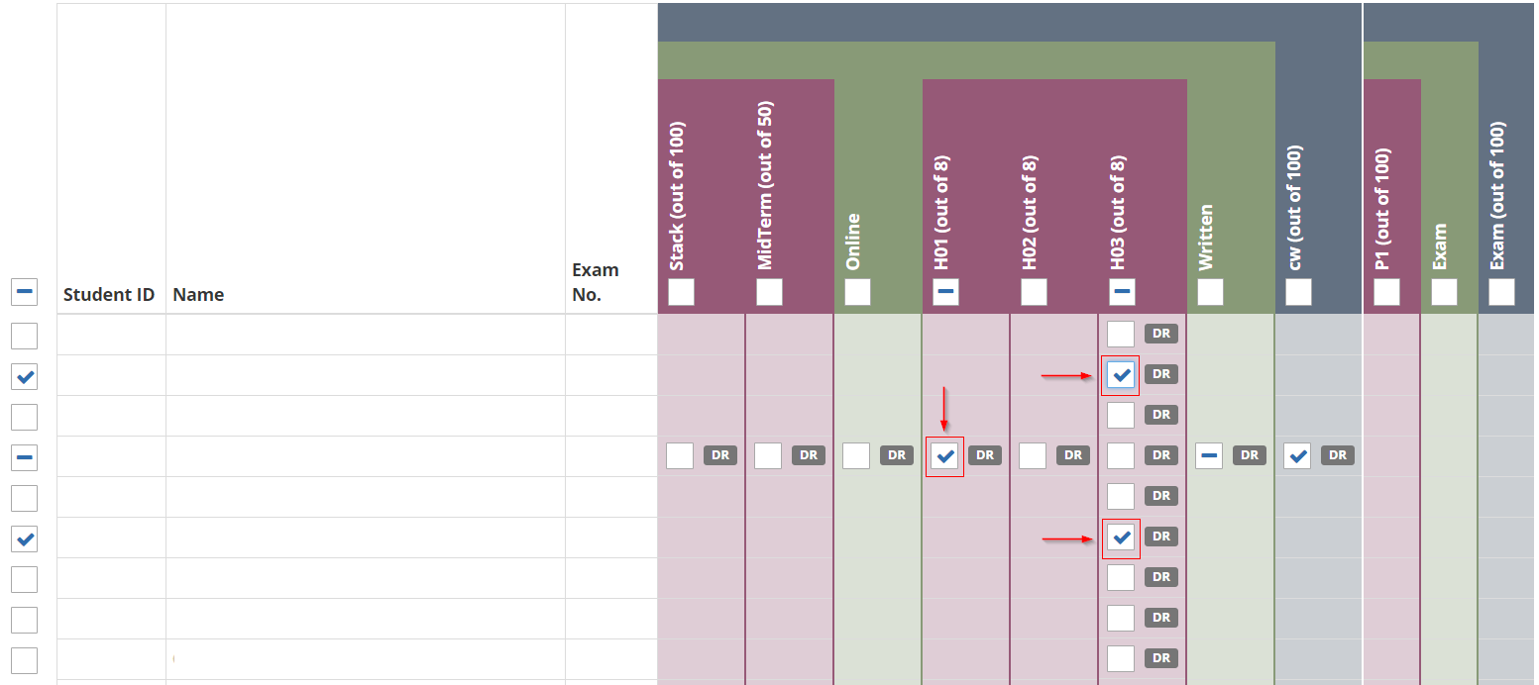

#### Undo for some students - all items, components, assessments

Tick the boxes to the left of the student ID/name/exam number:

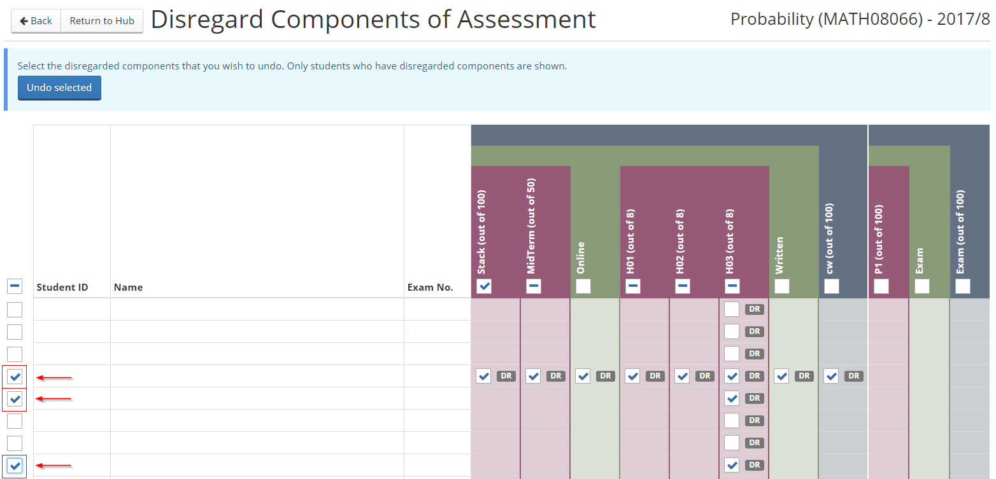

#### Undo for all students – only certain items, components, or assessments

Tick the “select all” box for the item, component, or assessment. This box sits under the name of the item/component/assessment:

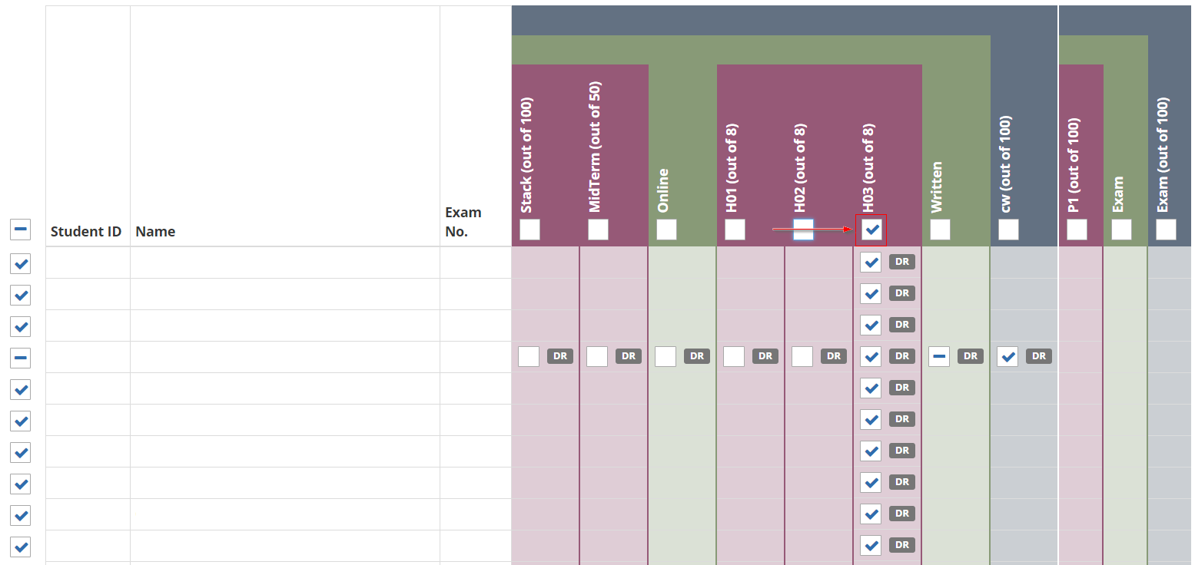

#### Undo for all students - all items, components, assessments

Tick the “select all” box on the left side of the page beside the student ID/name/exam number.

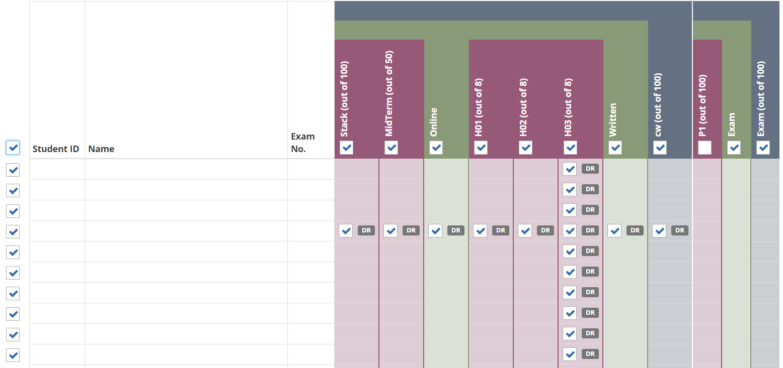

In the screenshot above all students, items, components, and assessments have now been selected. The only box without a tick is the “P1” item under the exam because no students have had this item disregarded.

### Click Undo selected

This button is on the left at the top of the page:

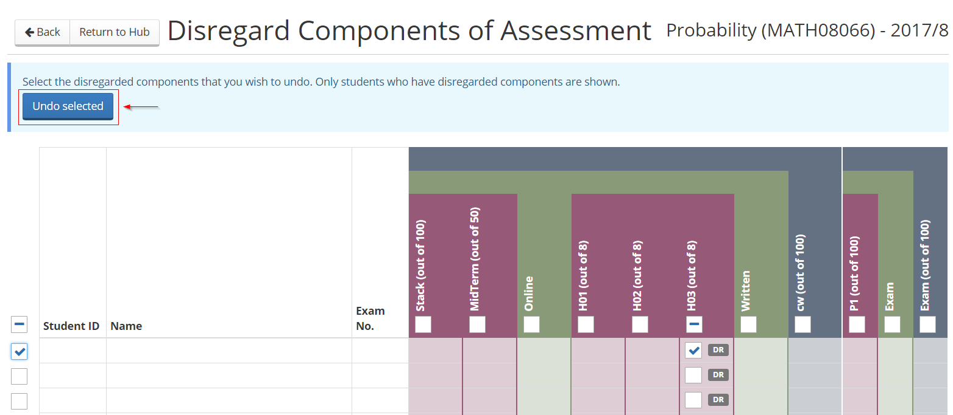

A prompt will appear asking you to confirm you want to undo the disregarding.

### Click continue

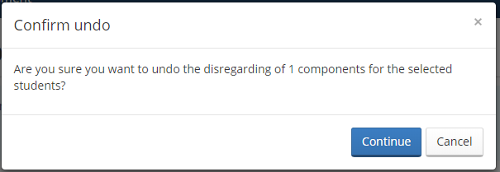

You will now see a confirmation message:

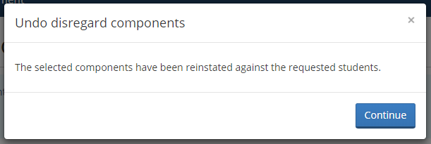

Click continue again.

The system will now return you to the Disregard components of Assessment page.

Click Return to Hub if you want to go back to the home page.

# **From the little i button**

Processing this task from the little i button is useful if you want to undo the disregarded components for one student at a time. From this screen you can un-disregard the item, component or assessment and then recalculate the marks and finish any other processing for the student.

## Process Overview

**1.** Click Ratify and publish

**3.** Locate the item, component, or assessment you want to undo

**2.** Locate the student and click the little i button

**6.** Save changes

**5.** Untick the disregard box

**4.** Click the entered mark value

## Step by Step Instructions

### Click Ratify and publish

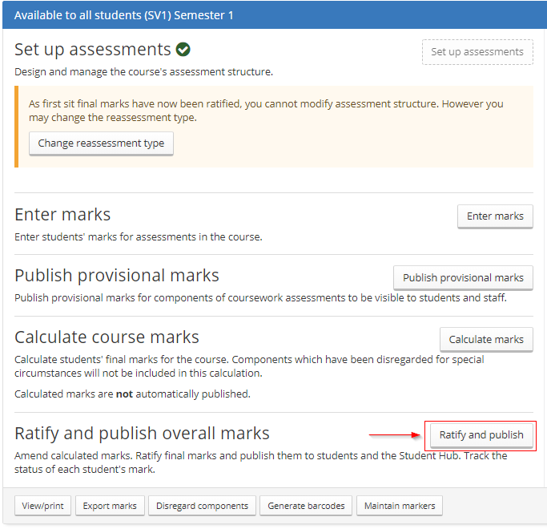

### Locate the student and click the little i button

You can search for the student by name or number in the search box, sort the columns by identifier, or scroll through the list.

The little i button is in the same cell as their student number:

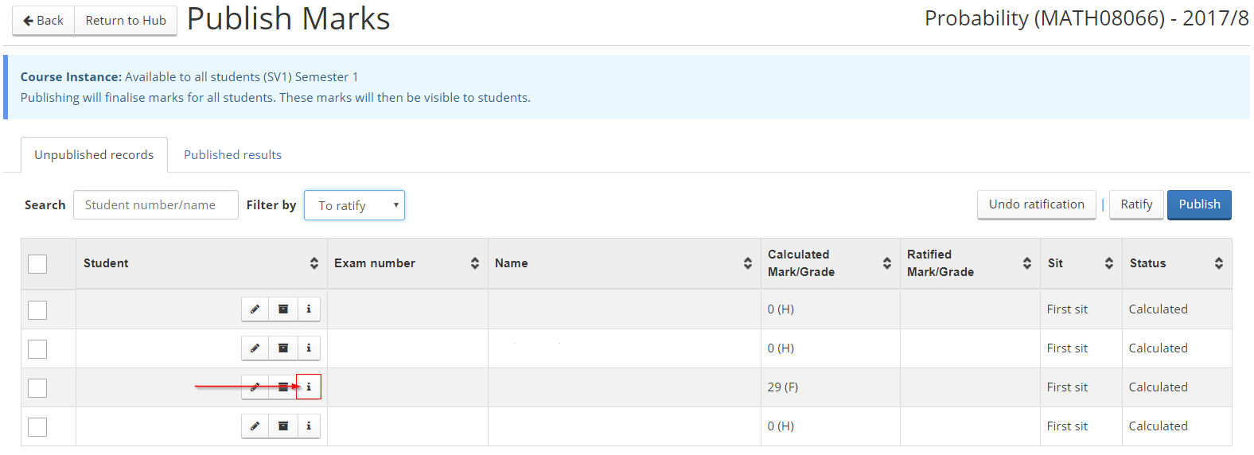

### Locate the item, component, or assessment you want to undo

This will be “greyed out” with diagonal lines going through it:

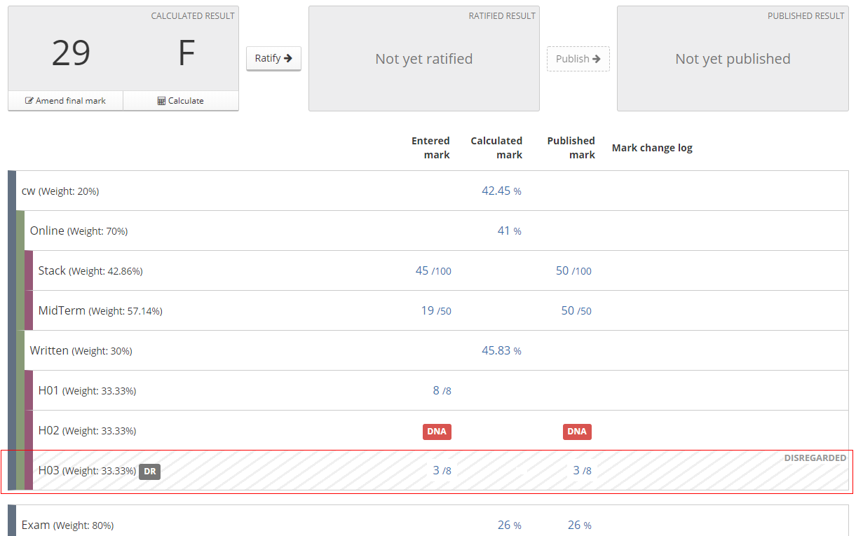

### Click the entered mark value



This link will open a pop up box to amend the mark.

### Untick the disregard box

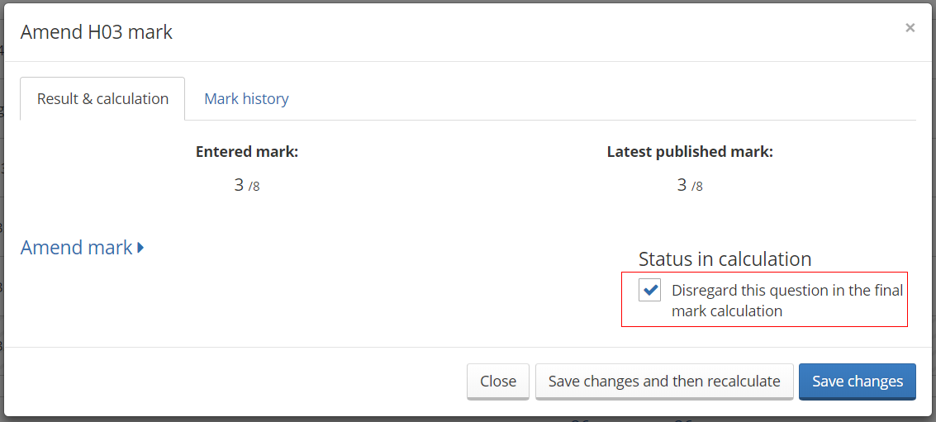

### Save changes

You can choose to save changes and then recalculate now, or just save changes without recalculating.

If you do not choose to recalculate now, you will need to remember to do this later as it won’t be automatically recalculated.

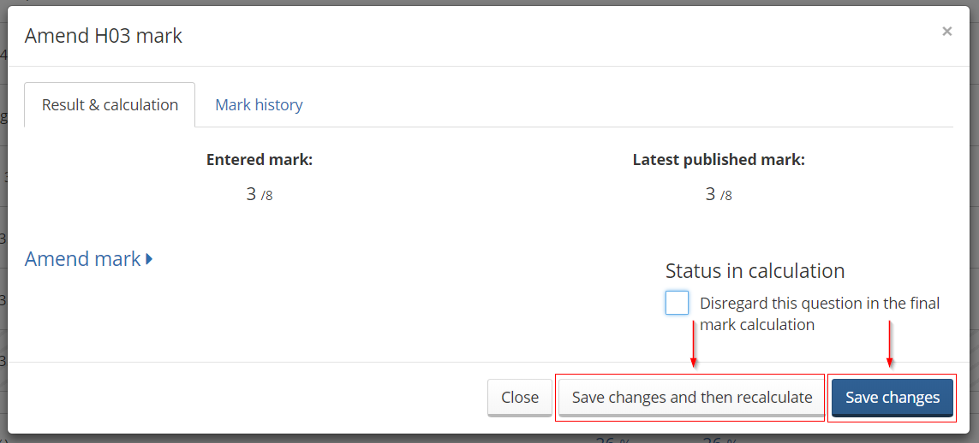

The item/component/assessment will now be included in the calculation again. The “greyed out” and diagonal lines should have now been removed:

